# Release 1 final test results

Unit tests  
Student_account: 16/16 passed

Welcome_Page:11/11 passed

Login Page: 5/5

Staff account management: 6/6 passed

Student account management: 5/5 passed

Contact_us: 1/1 passed

About_us: 1/1 passed

lessonBooking: 3/3 passed

Teacher_Contact: 1/1 passed

Integration tests:

Sprint 1: 5/5 passed

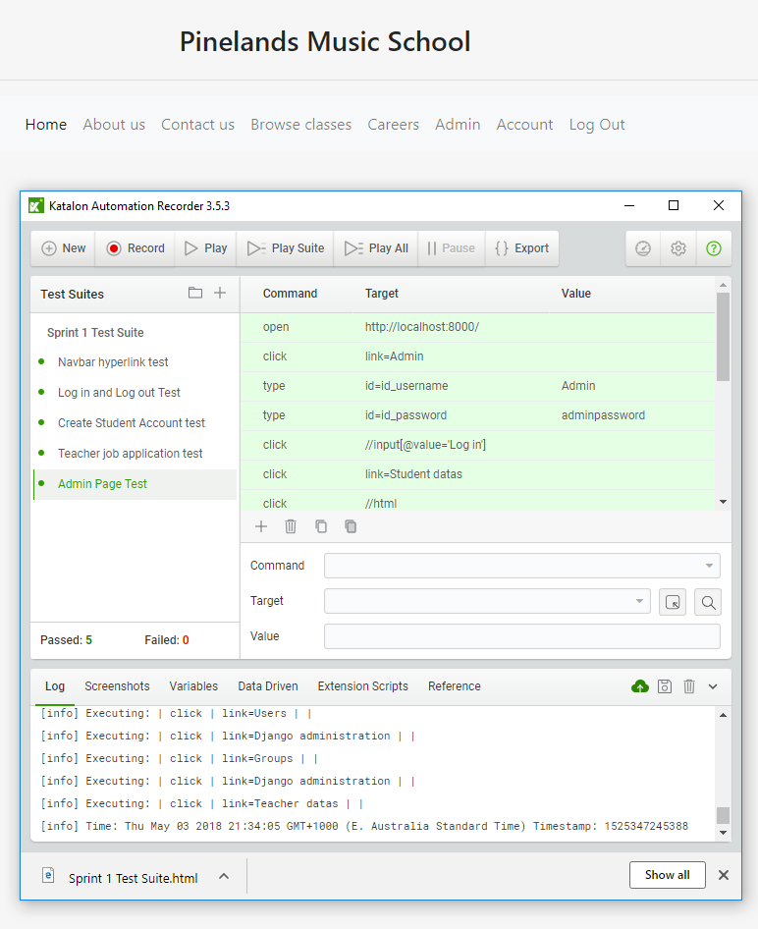

Sprint 2:

## Regression tests: 6/6 PASSED

### Sprint 1 old tests: 2/5 Passed

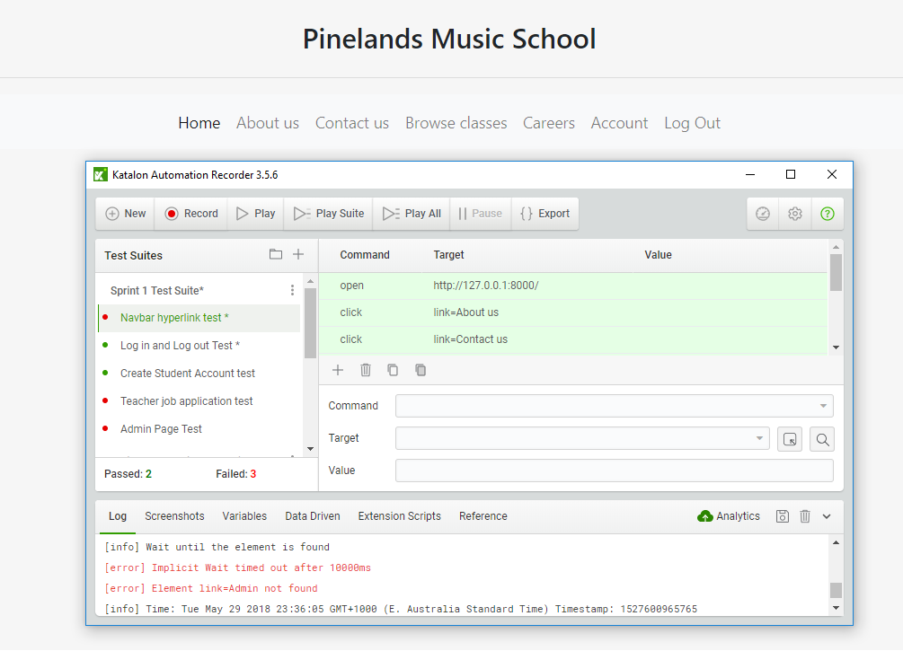

### Sprint 1 Regression test: 6/6 passed

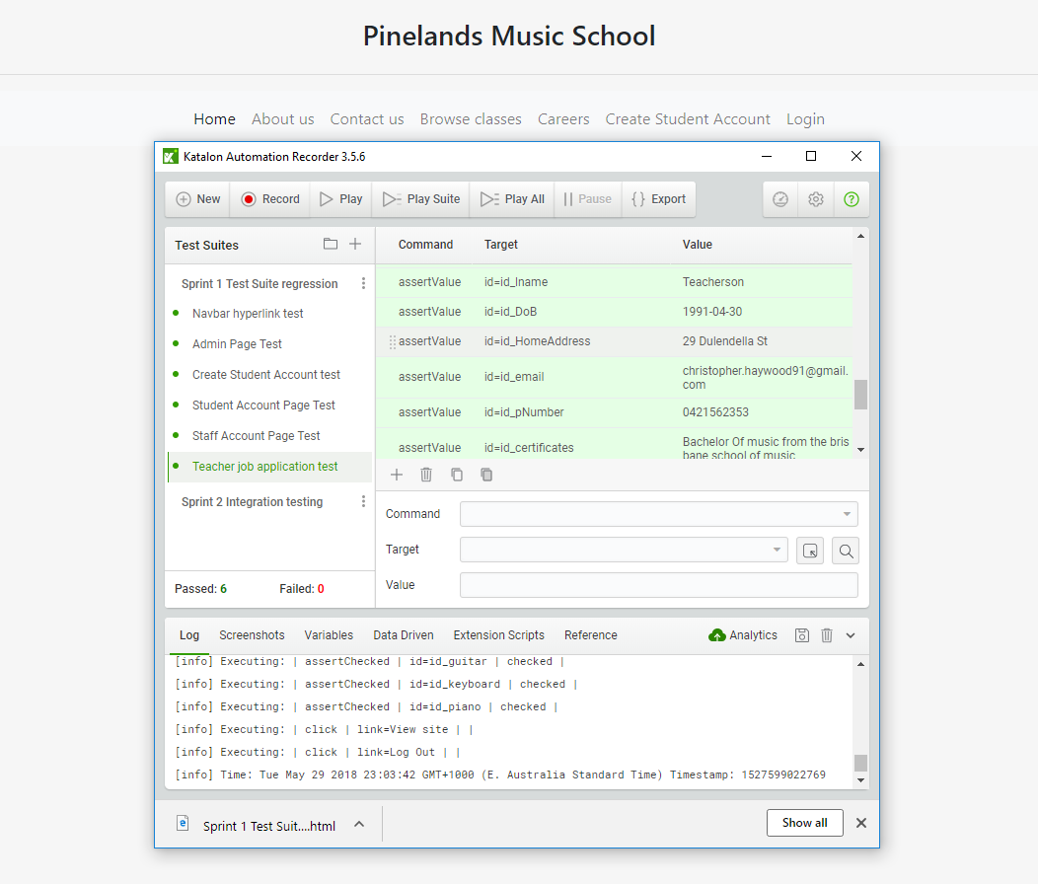

Back End Regression Tests

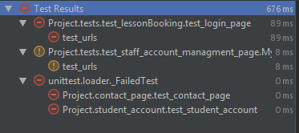

The above picture shows the tests from sprint 1 has failed in sprint 2. This was due to changes to url structures and page formatting which occured in sprint 2.

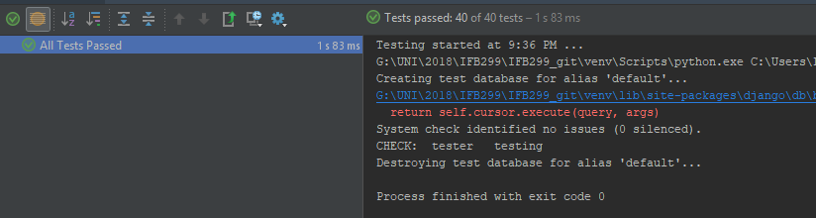

By implementing new unit tests and adjusting previously created tests, all unit tests now pass.